Bazarov Zhanserik
BDA – 2503
Github Link: https://github.com/zhanssss/ADS-Assignments/tree/master/Assignment%201/assignment-1
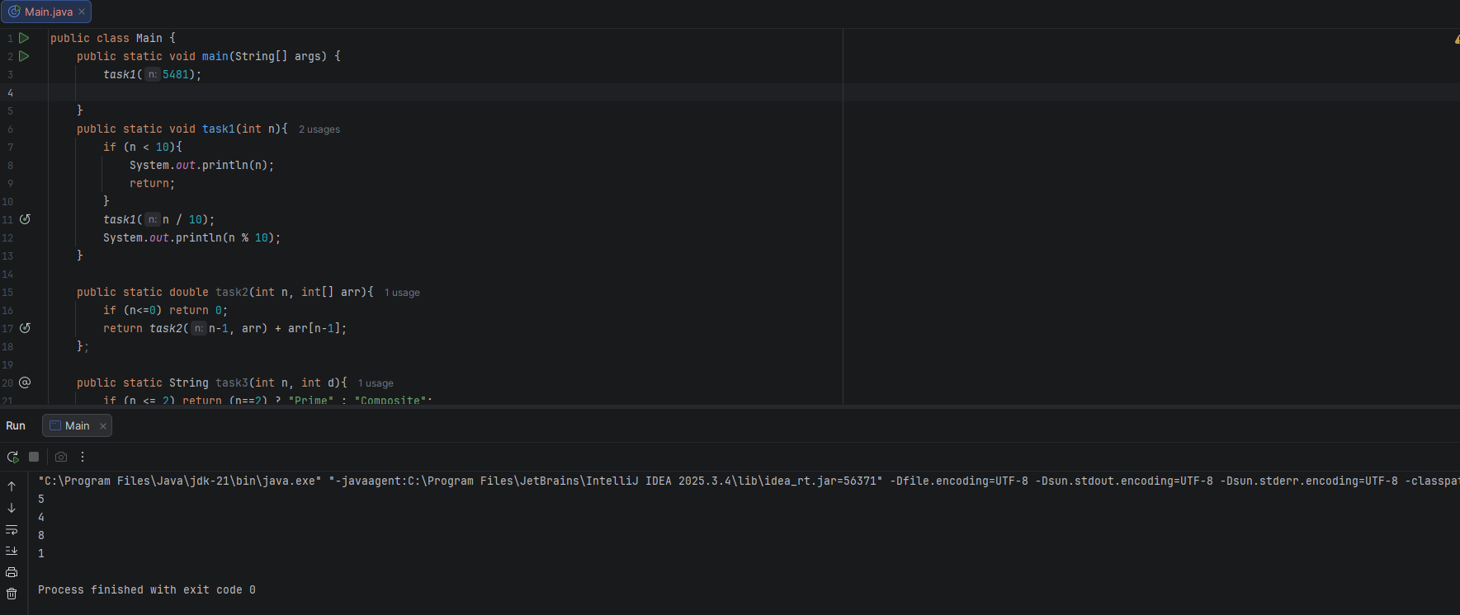
Task 1
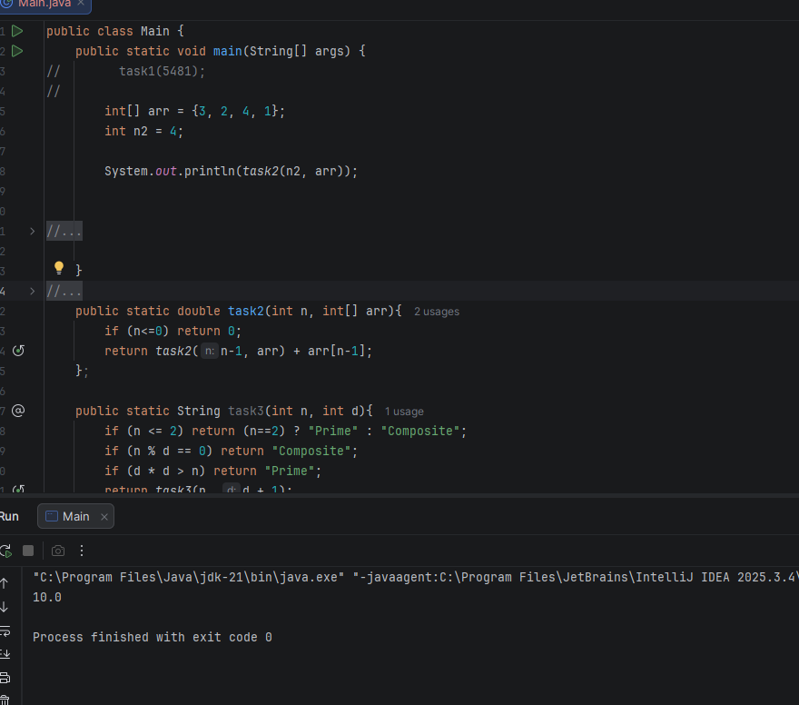
Task 2

Task 3
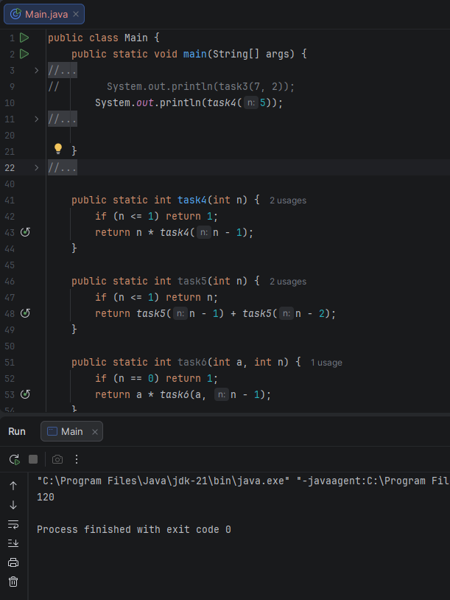
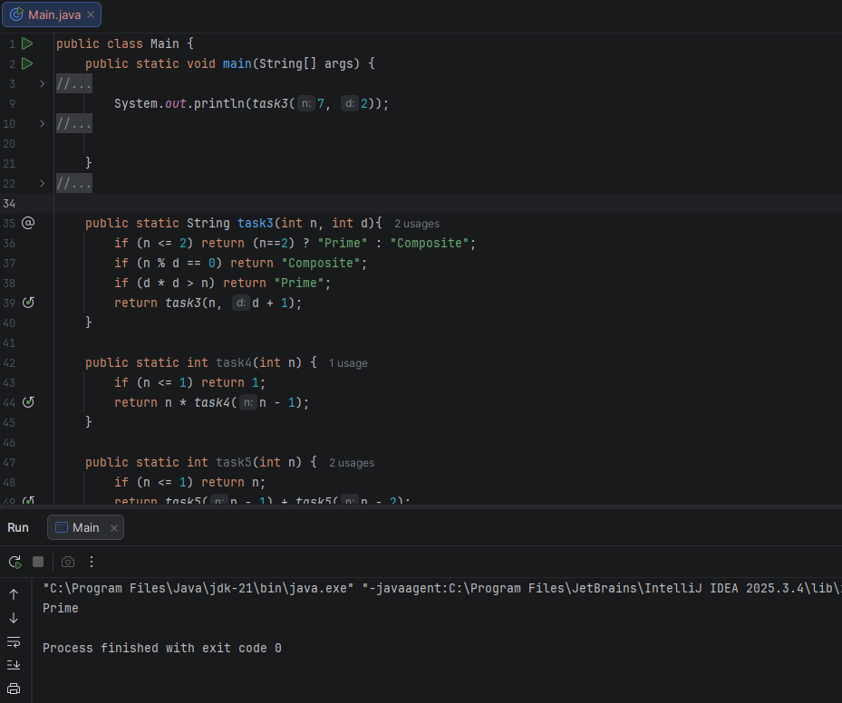Task 4

Task 5
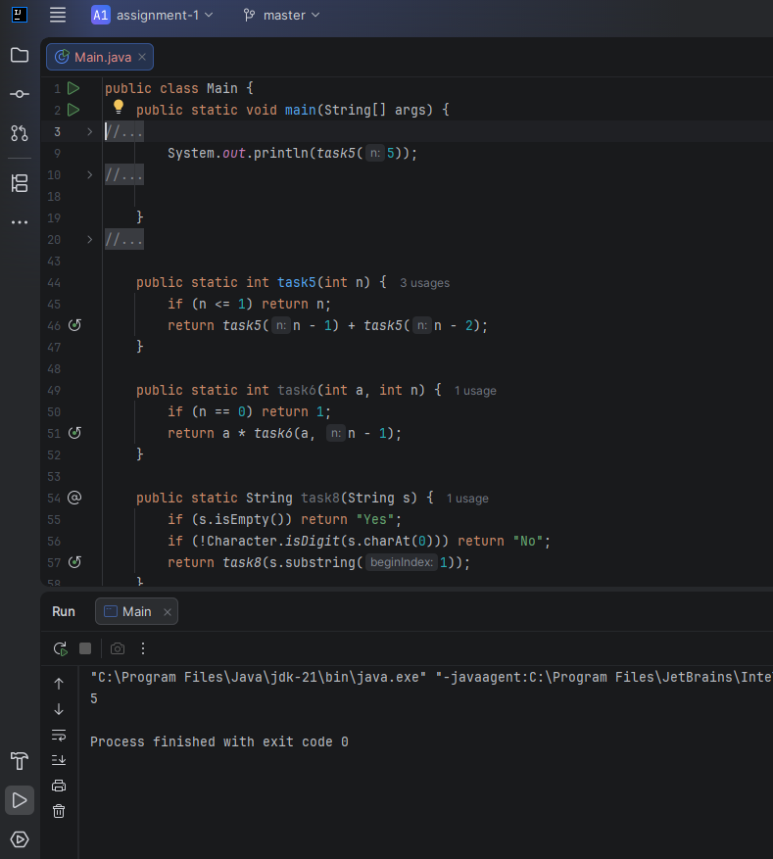

Task 6
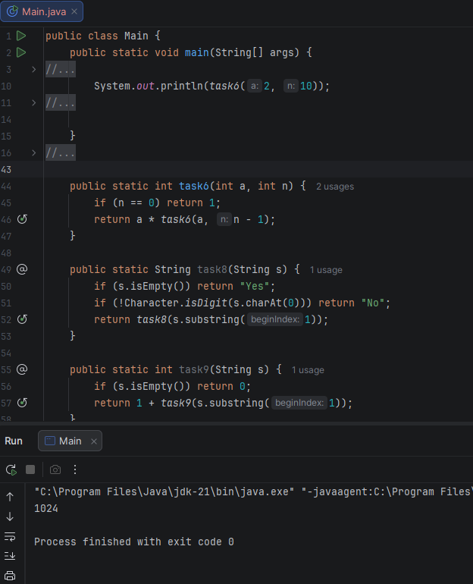

Task 8
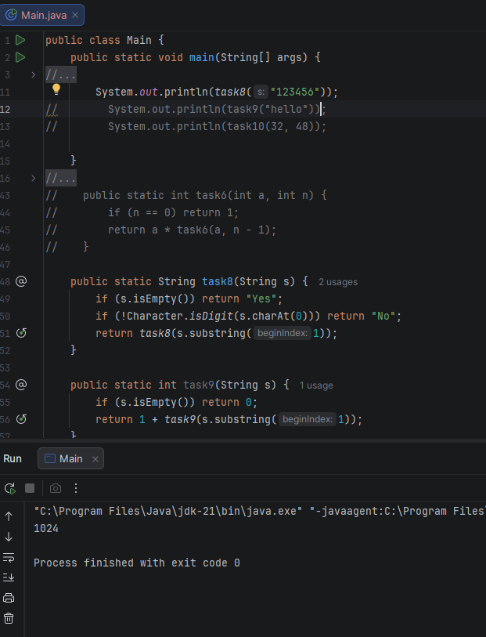

Task 9

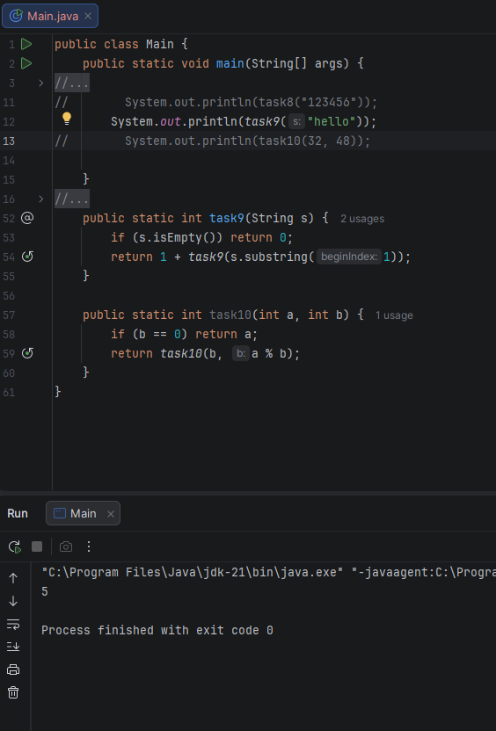

Task 10
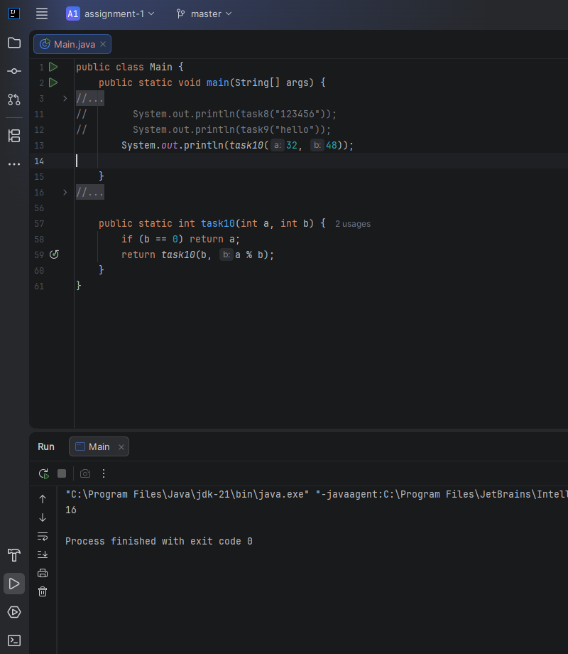

Summary: implemented ten recursive functions in Java to process numbers, sequences, and strings without using any loops as required by the assignment rules. Each solution includes a specific base case to stop the execution and a recursive step to solve the problem incrementally within the IntelliJ IDEA environment.

